**Path to Analytics Data**

Since a web browser does not allow access toa local machine, the path to the file must be added to appsettings.json in the AnalyticsDataReader project.

"LocalUploadPath": "C:\\Code\\AnalyticsDataReader\\",

**Data Model**

The Table the data points are saved to is [AnalyticalData]. The Meta data on the upload is saved to table [AnalyticalMetaData]. There is purposefully no foreign key linking them to save space on the db as large data sets could be uploaded. The Dataset could be uniquely identified using the SeriesStartID and SeriesEndID fields on [AnalyticalMetaData].

**Deploying Database to Azure**

On the Home page click on Database

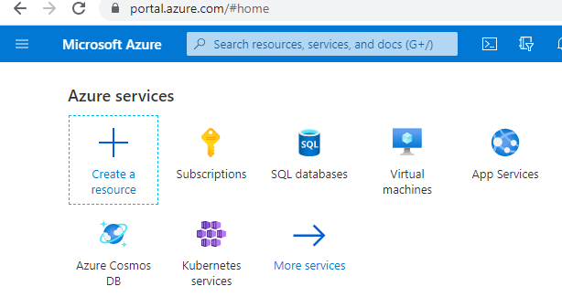

Click on Add

Edit field as seen below.

On The right hand panel fill in Server Name admin login and passwords.

Once done click on Review and Create.

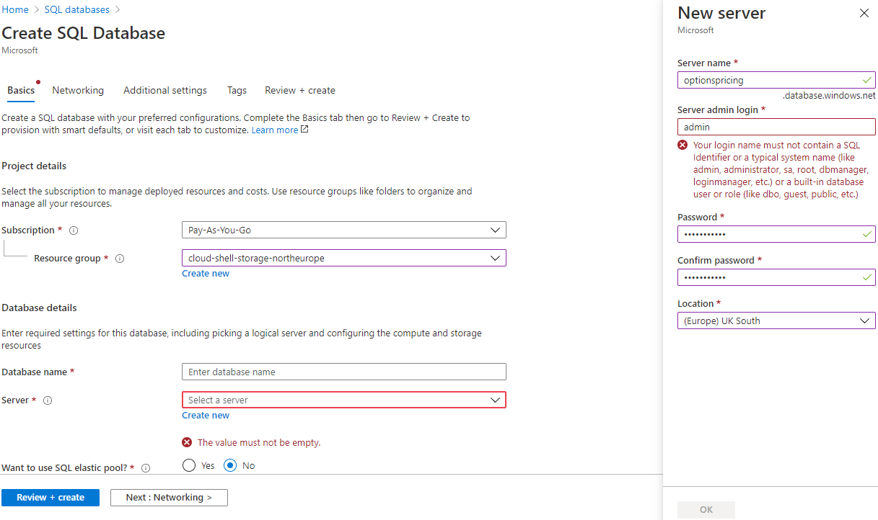

## New database created in this example is Microsoft.SQLDatabase.newDatabaseNewServer_d45e8b3bdf394d6689d83.

## To deploy local SQL Database to Azure, Open SQL Server Management studio.

## 

## Connect to Azure Database

## 

Open New Query and execute table creation script named \AnalyticsDataReader\AnalyticsDataReader\AnalyticsDataReader.DAL\DB Creation Scripts

Add new connection string to Web \Api\AnalyticsDataReader\AnalyticsDataReader\appsettings.json file

Retrieve connections string from SQL click ‘Show database connection String’

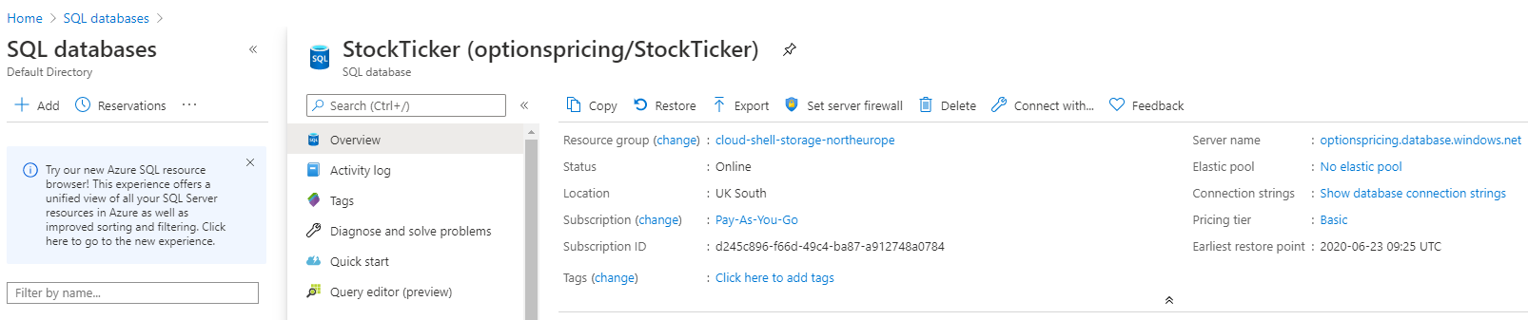

Server=tcp:optionspricing.database.windows.net,1433;Initial Catalog=AnalyticsTool;Persist Security Info=False;User ID=dbadmin;Password={your_password};MultipleActiveResultSets=False;Encrypt=True;TrustServerCertificate=False;Connection Timeout=30;

Edit File appsettings.json in project AnalyticsDataReader in visual studio community

Start Project and ensure data is in database using web call [**https://localhost:44325/api/AnalyticalData/GetAnalyticalDataAll**](https://localhost:44325/api/AnalyticalData/GetAnalyticalMetaDataAll) **in** browser

**Open and execure Angular web Front end**

Using visual studio code open angular project ‘AnalyticalUIClient.

Edit proxy.conf.json. Insert port that is used by Web API project.

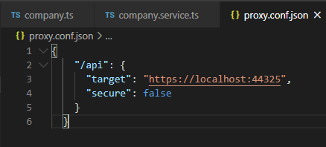

Launch Angular UI by issuing below command in the Terminal Window.

ng serve --port 4201 --proxy-config proxy.conf.json

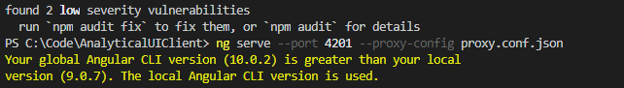

Navigate to website shown in Terminal window, http://localhost:4201/



Data Displayed as seen below

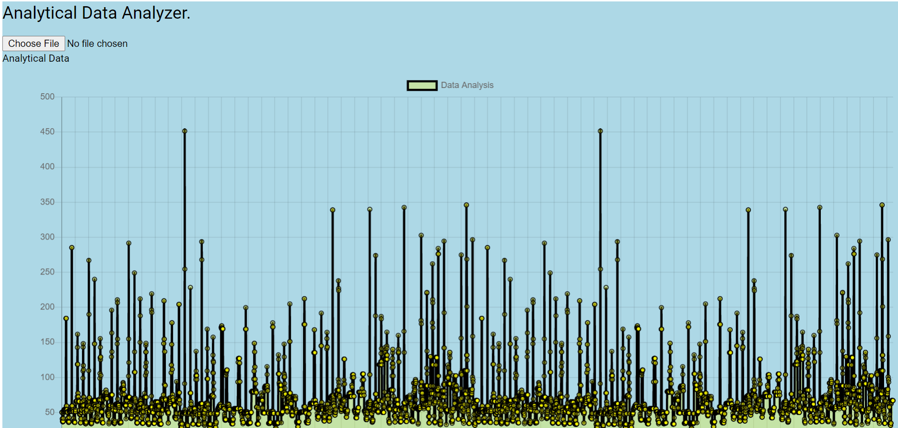

Meta Data displayed in Grid as shown

